Empowering Change:
The
Journey of
Narita
Basumatary Dihira, Baksa.
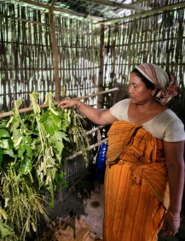
Age: 45 years
Gender: Female
Husband: Rabindra Basumatary
Children: 4 Children
What does SANJOG do?
SANJOG is a civil society organization established on the 12th of June 2014. The organization's thematic area of work is promotion of rural livelihood by approaching convergence and collaboration with other foundations like Azim Premji Foundation, SELCO foundation, IDeA, RCRC, Assam State Rural Livelihood Mission etc. SANJOG works in 39 villages of Barpeta, Nalbari, Baksa, and Udalguri districts in Assam state and has a vision of adding 50 to 60 villages in the coming 3 years.
Who is Narita Basumatary? 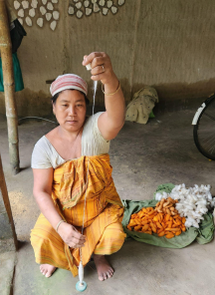
Narita Basumatary is a marginal farmer from village Dihira of Nikashi panchayat of Baska Block in Baksa district. She is a member of Bwhwithi SHG. She falls under the BPL category. Her family includes husband Rabindra Basumatary and has 4 children. Rabindra works as a daily wage laborer in the village. Narita Basumatary’s family owns 2 bighas of agricultural land and they cultivate paddy for their own consumption. Initially she started vegetable vending to save family from the economic crisis. They as a family own 18 goats and 15 poultry birds. From all the occupations they earn about 42,000 in a year.Growing up in a rural setting, she was intimately familiar with the challenges faced by farmers, especially women. Despite these challenges, Narita's passion for agriculture and a better future for her
community drove her to pursue a path less traveled.
How did she come in contact with SANJOG?
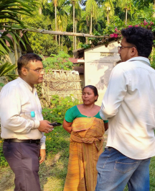
She came in contact with SANJOG in 2022. In ASRLMs Block development office, when SANJOG wanted to start intervention related “Eri silk spinning” in collaboration with “Resham Sutra” they came to know about Mrs. Basumatary the hard worker. Despite her qualifications, social customs and family barriers did not prevent Norita from finding an additional source of income. After coming in contact with SANJOG, she was provided support in the form of training and introduced her to rear yarn with the help of a machine. She has been monitored by SANJOG’s field executives. She thinks coming in contact with SANJOG and choosing silk rearing in a machine as the biggest compliment in
her life. This machine further helped her in earning.
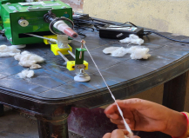
Impact on self and the community
Narita has started earning 4000 rupees in a month which was only 1000 rupees before she came in contact with SANJOG. Her income has increased by 300% in a month. Narita’s initiatives have had a transformative impact on her community. Through her cooperative, she has trained over 200 women in sustainable Eri rearing practices, significantly improving their income levels and standard of living. Her efforts have also led to a noticeable increase in women participation in decision making and to have a say in the family.
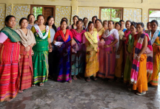
Cost Analysis
1 KG cocoon costs 800 rupees, for a KG of thread it requires one and half kilo of cocoons which is 1200 rupees and the electricity cost will be around 400 rupees in a month and the human effort. In total it costs around 1600 rupees to earn 4000 rupees. She was earning only thousand rupees in a month by spinning with hand by producing 250 grams of yarn. After she started working in a machine, she earns 4000 rupees in a month. After she started earning, eventually she started rearing on her own and it reduces the cost of buying cocoons from outsiders, now she sells all the requirements for silk rearing and she earns from that. As she mentioned 5000 rupees by selling the requirements.
Conclusion
Narita Basumatari's story shows the strength of resilience, innovation, and community action. From being a struggling farmer, she became a successful agricultural entrepreneur, greatly impacting her community. Her work has not only improved many people's lives but also empowered women in her village. Narita Basumatary intends to expand her business in near future so as to provide her family with a better standard of living. With a monthly income of 15,000 rupees, Narita Basumatary is expecting to earn nearly a half a lakh in this year. Her association with this programme helped her build a sustainable livelihood and live a life of dignity and respect.

